**More on sed**

**Use the same text file seddemo.txt**

1. 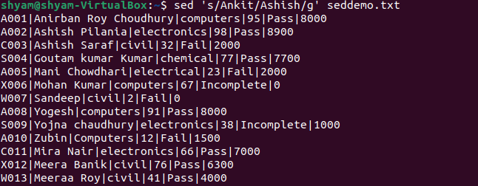**Try to replace or substitute name Ankit with Ashish**